ABSTRACT

MOBILE BASED EXPERT SYSTEM. In this project used for, sometimes you come across small problems with your phone where you to need to consult an expert, give it to him, get it repaired and receive it after a few days or after some hours to take your phone. This is inefficient.
Mobile Based Expert System will provide you direct interaction with the experts of your choice as and when required for your problems. Using this system, users will be able to fill online form in just few seconds before entering into the virtual office room. If they do not find their required expert, they can make use of the expert system provided. If they do not find a solution, they can contact us regarding their queries.

CHAPTER 1 - INTRODUCTION

1.1 PROJECT OBJECTIVE:
To make a truly useful system to have a meet with online experts, all manual process has been automated through this system. Users have to fill online form by which id and password are created. Through this panel, users can select the experts and have a chat with them on their time from their own place. If their expert is not available, they can make use of the expert system.
1.2 PREVIOUS SYSTEM:
Under previous system, you have to first wait in line and wait for your time to have meet with the expert (say repairer) and discuss about your phone’s problems. You have to visit on another day or after some hours to take your phone. This is inefficient.
1.3 PROPOSED SYSTEM:
A Mobile Based Expert System which provides you direct interaction with the experts and discuss about problems with your phone. Using this system, users can get advice from certified experts. If they do not find their required expert they can also make use of the expert system provided.
1.4 ADVANTAGES:
- Instead of visiting an expert, users can have an online interaction with him.
- Instead of consulting an unknown repairer, you can find certified experts in our system.
- Our expert system provides you an advice, if experts are unavailable.
- This system saves a lot of time and money.
- The usage of this system is absolutely free.

1.5 MODULES:
- User Form and Login Module.
- Adding and Removing Experts Module.
- Online Chat with Expert Module.
- Expert system Module.

MODULE DESCRIPTION:

1. User Form and Login Module: For the first time visitors, they have to just enter their details, register and then login and can enter their dashboard. System will take care of creating their new profile. For existing users, they will have to enter their id and password to login. This module will be like a virtual office from where all activity can be performed.

2. Adding and Removing Experts Module: Through this module, users can add experts to have discussion regarding the problems with their phone. Users can also remove those experts if they do not want to refer him/her again.
3. Online Chat with Expert Module: Users and Experts can send messages to each other through this module. Phone problems and their solutions can be discussed in those messages.

4. Expert system Module: Users can select the problems they are facing with their phones in the checkboxes provided and an advice generated from the system is displayed. This system provides solutions for problems of phones using 3 widespread operating systems namely:
  - Android
  - iOS
  - Windows

1.6 EXPERT SYSTEMS

INTRODUCTION:
An expert system is a computer application developed to solve a complex problem in a particular domain, which ordinarily requires human expertise [1]. Expert system development software is ideal for capturing diagnostic and repair knowledge to produce interactive on-line systems that provide detailed, situation-specific advice comparable to talking to an expert. End users can access an interactive system from any web browser, answer some questions and get precise advice on systematically diagnosing problems and recommended steps for repair [2].
Typically, an expert system incorporates a knowledge-base containing accumulated experience and an inference or rules engine -- a set of rules for applying the knowledge base to each particular situation that is described to the program. The system's capabilities can be enhanced with additions to the knowledge base or to the set of rules. Current systems may include machine learning capabilities that allow them to improve their performance based on experience, just as humans do [4].
The concept of expert systems was first developed in the 1970s by Edward Feigenbaum, professor and founder of the Knowledge Systems Laboratory at Stanford University. Feigenbaum explained that the world was moving from data processing to "knowledge processing," a transition which was being enabled by new processor technology and computer architectures [4].
Expert systems have played a large role in many industries including in financial services, telecommunications, healthcare, customer service, transportation, video games, manufacturing, aviation and written communication. Two early expert systems broke ground in the healthcare space for medical diagnoses: Dendral, which helped chemists identify organic molecules, and MYCIN, which helped to identify bacteria such as bacteremia and meningitis, and to recommend antibiotics and dosages [4].
Expert systems and AI systems have evolved so far that they have spurred debate about the fate of humanity in the face of such intelligence [4].
FEATURES:
- High performance.
- They are easily understandable.
- They are reliable.
- They are also highly responsive [2].
ADVANTAGES:
- They are capable of advising.
- They are able to assist humans in decision making.
- They help us in diagnosing.
- They are capable of predicting results.
- They can also suggest alternative solutions to a problem.
- They are easily available due to mass production of software.
- Production cost is reasonable. This makes them affordable.
- They offer great speed and Less Error Rate. [2].
DISADVANTAGES:
- They couldn’t substitute human decision makers.
- They cannot produce accurate output if there is an inadequate knowledge base.
- They do not get refined on their own. It is the developer who has to update its database regularly with the latest knowledge [2].
ARCHITECTURE:
COMPONENTS:
- Knowledge Base
- Inference Engine
- User Interface

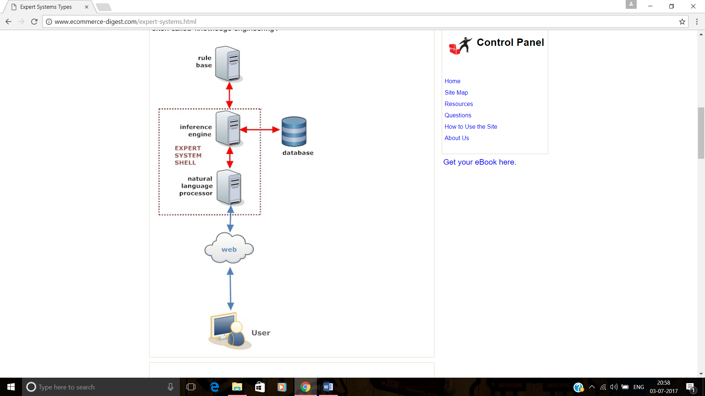
Fig 1.6.1: Expert System Architecture. [3].

KNOWLEDGE BASE:
It contains knowledge. Knowledge is nothing but Data, information, and past experience combined together. For any ES to be successful, it majorly depends upon the collection of accurate and precise knowledge [3].

INFERENCE ENGINE:
Inference engine contains procedures and rules. It acquires and manipulates the knowledge from the knowledge base for arriving at a correct solution [3].
To recommend a solution, the Inference Engine uses the following strategies:
- Forward Chaining
- Backward Chaining
FORWARD-CHAINING:

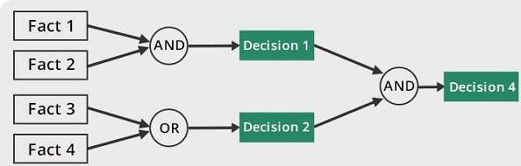

Fig 1.6.2: Forward Chaining

BACKWARD-CHAINING
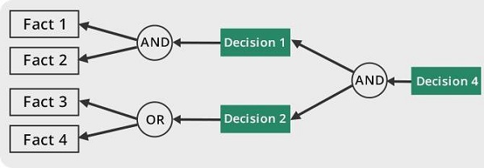

Fig 1.6.3: Backward Chaining

USER INTERFACE:
User interface provides interaction between user of the ES and the ES itself. It is generally Natural Language Processing so as to be used by the user. The user of the ES need not be necessarily an expert [3].
TYPES OF EXPERT SYSTEMS:
- Knowledge based
- Rule based

Knowledge based:

It contains domain knowledge, normally provided by human experts. It is typically very specialized for a particular problem domain and is often encoded as IF-THEN rules [7].

Rule based:

Instead of representing knowledge in a declarative, static way as a set of things which are true, rule-based system represent knowledge in terms of a set of rules that tells what to do or what to conclude in different situations [7].

APPLICATIONS:
- Design Domain: Camera lens design, automobile design.
- Medical Domain: Diagnosis Systems to deduce cause of disease from observed data, conduction medical operations on humans.
- Monitoring Systems: Comparing data continuously with observed system or with prescribed behavior such as leakage monitoring in long petroleum pipeline.
- Process Control Systems: Controlling a physical process based on monitoring.
- Knowledge Domain: Finding out faults in vehicles, computers.
- Finance/Commerce: Detection of possible fraud, suspicious transactions, stock market trading, Airline scheduling, cargo scheduling. [6]

1.7 HARDWARE AND SOFTWARE REQUIREMENTS:

Hardware Requirements:
- Hardware - Pentium
- Speed - 1.1 GHz
- RAM - 1GB
- Hard Disk - 20 GB
- Floppy Drive - 1.44 MB
- Key Board - Standard Windows Keyboard
- Mouse - Two or Three Button Mouse
- Monitor - SVGA

Software Requirements:
- Operating System : Windows
- Technology : PHP
- Web Technologies : Html, JavaScript, CSS
- IDE : Notepad++
- Web Server : Wamp2.2e
- Database : My SQL

CHAPTER 2 – SOFTWARE REQUIREMENT SPECIFICATIONS

2.1 ACTORS:
There are three actors in our system namely:
- Admin
- Expert
- Client

ACTORS | DESCRIPTION
Admin | - Admin can add new experts.  - Admin can remove existing experts.
Expert | - Expert receives messages from his clients.  - Expert can send replies to those messages.
Client | - Client can add and remove experts.  - Client can send and receive messages from experts.  - Client can use the expert system to find solutions for his mobile related problems.
Table 2.1.1: Actors and Description

2.2 USE CASE DIAGRAMS: [9]
ADMIN:
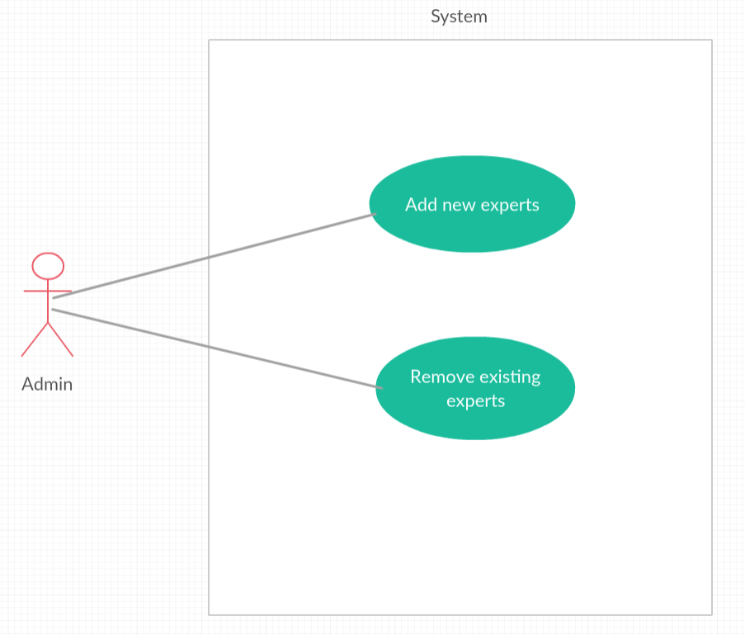
Fig 2.2.1: Admin Use Case Diagram
In the above use case diagram we have
Actor: Admin
Use Cases:
- Add new Experts
- Remove existing Experts

EXPERT:
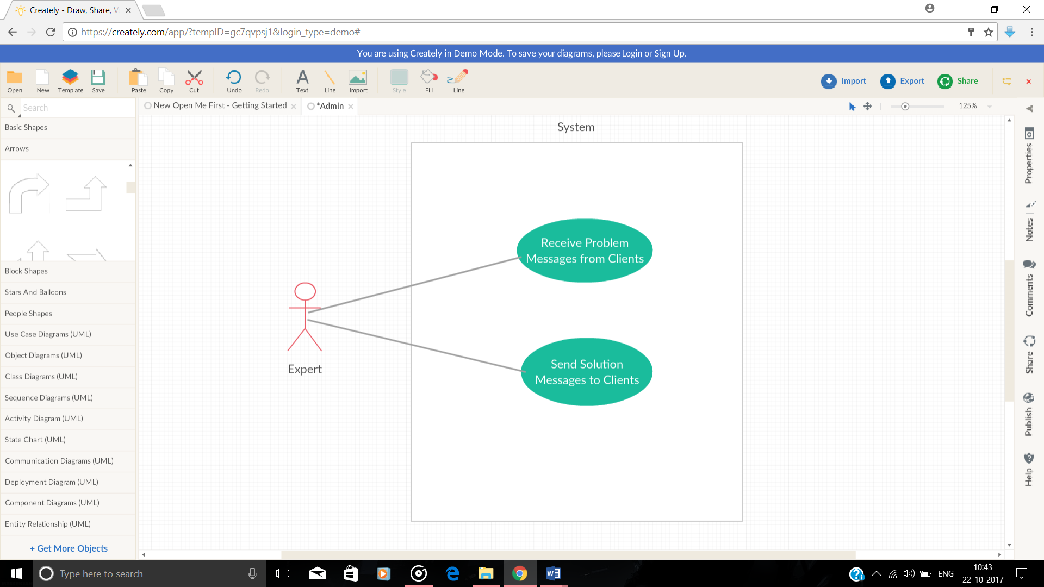
Fig 2.2.2: Expert Use Case Diagram
In the above use case diagram we have
Actor: Expert
Use Cases:
- Receive Problem messages from Clients
- Send Solution messages to Clients

CLIENT:
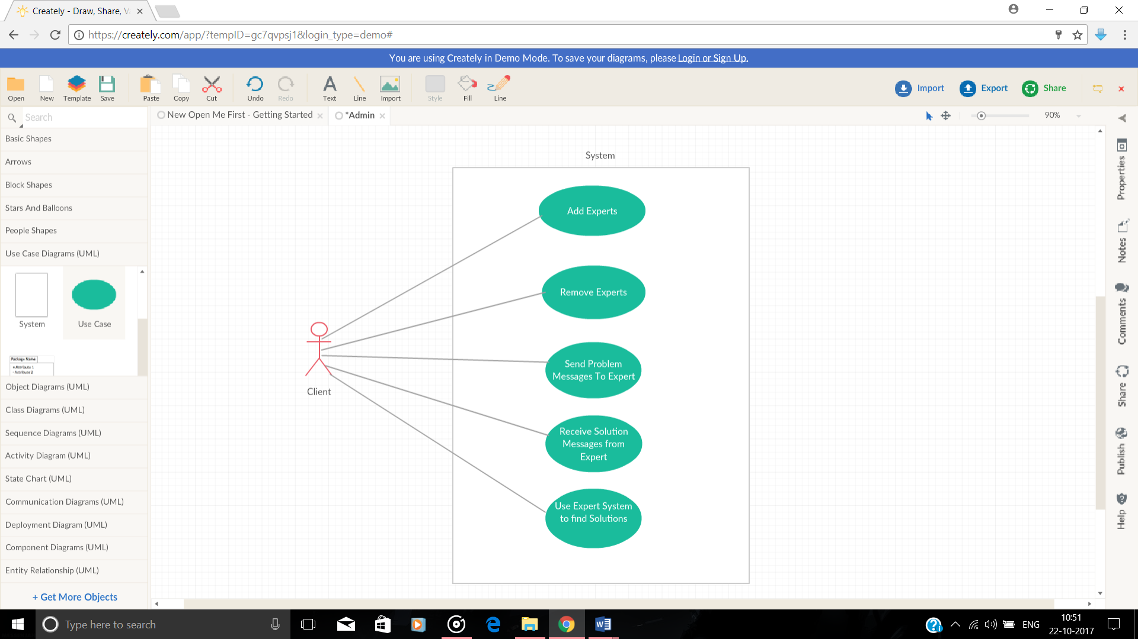
Fig 2.2.3: Client Use Case Diagram
In the above use case diagram we have
Actor: Client
Use Cases:
- Add Experts
- Remove Experts
- Send Problem messages to expert
- Receive Solution messages from expert
- Use the Expert System
2.3 PROGRAM FILES:
We have the following programming files in our project:
- index.php
- logins.php
- about.php
- adm_login_form.php
- login_form.php
- contact.php
- home.php
- profile.php
- edit_profile.php

2.4 PARAMETERS AND USER MANUAL: [8]
index.php:
PARAMETERS: None
It contains the code for the home page of the website and it contains register, login, contact us and logins and about us on the navigation bar.
Now let us look at the admin, expert and client manuals for this page and what all the functions they can perform.

ADMIN MANUAL:
Admin can: login, add new experts or remove existing experts and logout.

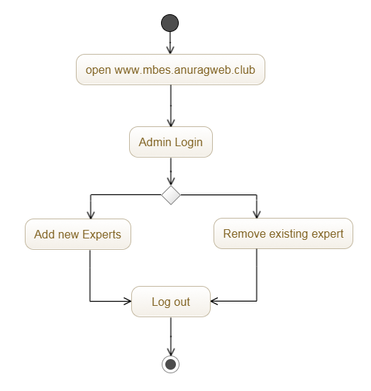
Fig 2.4.1: Admin Activity Diagram

EXPERT MANUAL:
Expert can: login, edit profile, interact with clients and logout.

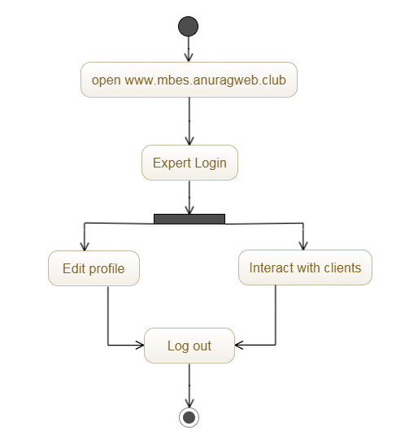
Fig 2.4.2: Expert Activity Diagram
CLIENT MANUAL:
Client can: sign up, if he is a new user.
Client can: login, edit profile, interact with expert or use expert system and logout.
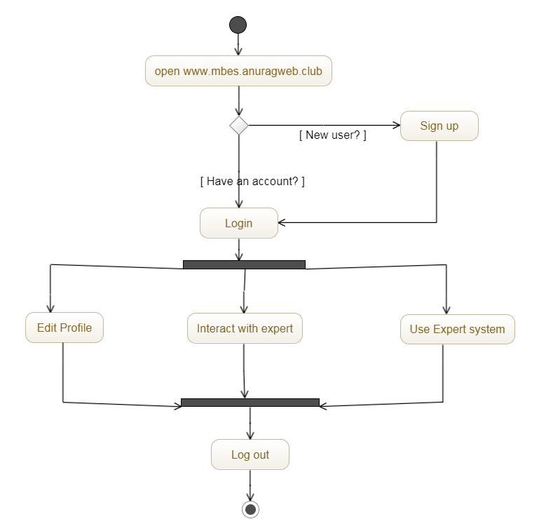
Fig 2.4.3: Client Activity Diagram

2.5 METHOD OF IMPLEMENTATION:
HTML:
Hypertext Markup Language (HTML) is the standard markup language for creating web pages and web applications. HTML elements are the building blocks of HTML pages. With HTML constructs, images and other objects, such as interactive forms, may be embedded into the rendered page. It provides a means to create structured documents by denoting structural semantics for text such as headings, paragraphs, lists, links, quotes and other items. HTML can embed programs written in a scripting language such as JavaScript which affect the behavior and content of web pages.

CSS:
Cascading Style Sheets (CSS) is a style sheet language used for describing the presentation of a document written in a markup language. Along with HTML and JavaScript, CSS is a cornerstone technology used by most websites to create visually engaging web pages, user interfaces for web applications, and user interfaces for many mobile applications. CSS is designed primarily to enable the separation of presentation and content, including aspects such as the layout, colors, and fonts.

PHP:
PHP is an HTML-embedded server side scripting language designed for web development. It is also used as general purpose programming language. It was created by Rasmus Lerdorf in 1994 and appeared in the market in 1995. Much of its syntax is borrowed from C, C++, and Java. PHP codes are simply mixed with HTML codes and can be used in combination with various web frameworks. Its scripts are executed on the server. PHP code is processed by a PHP interpreter. The main goal of PHP is to allow web developer to create dynamically generated pages quickly.

2.6 USER SCREENS:
HOMEPAGE:
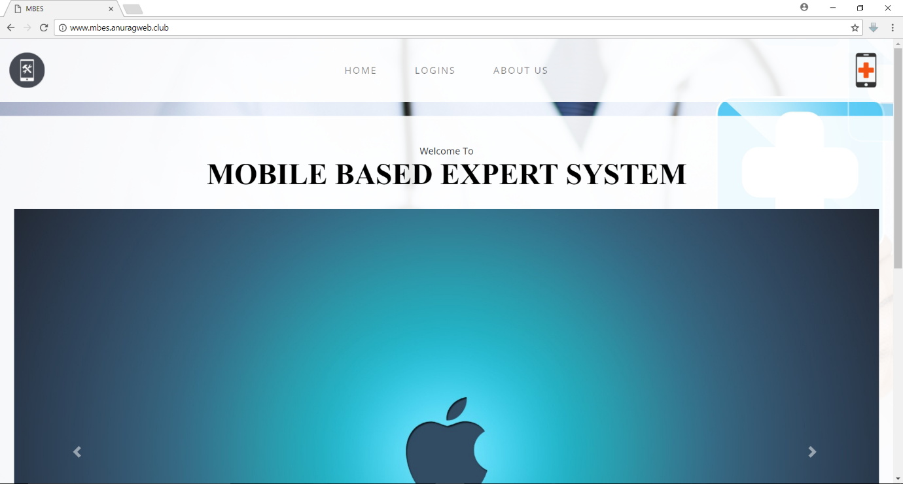

LOGINS:
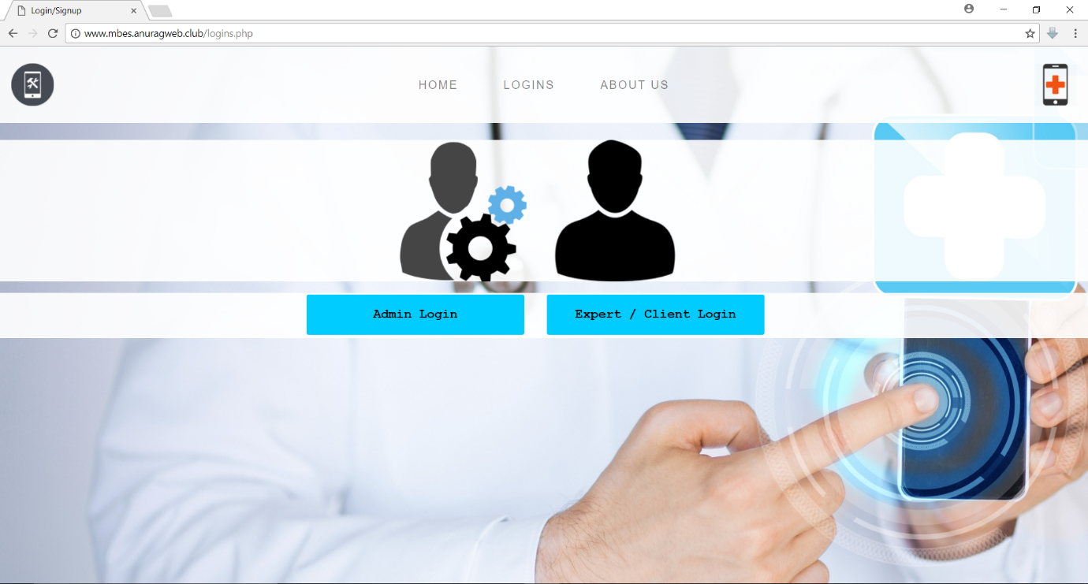

ABOUT US:
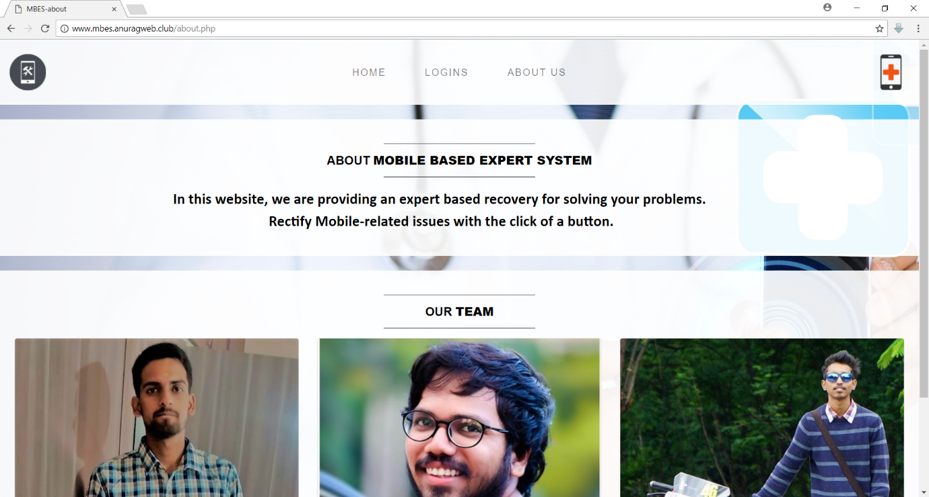

EXPERT/CLIENT LOGIN PAGE:
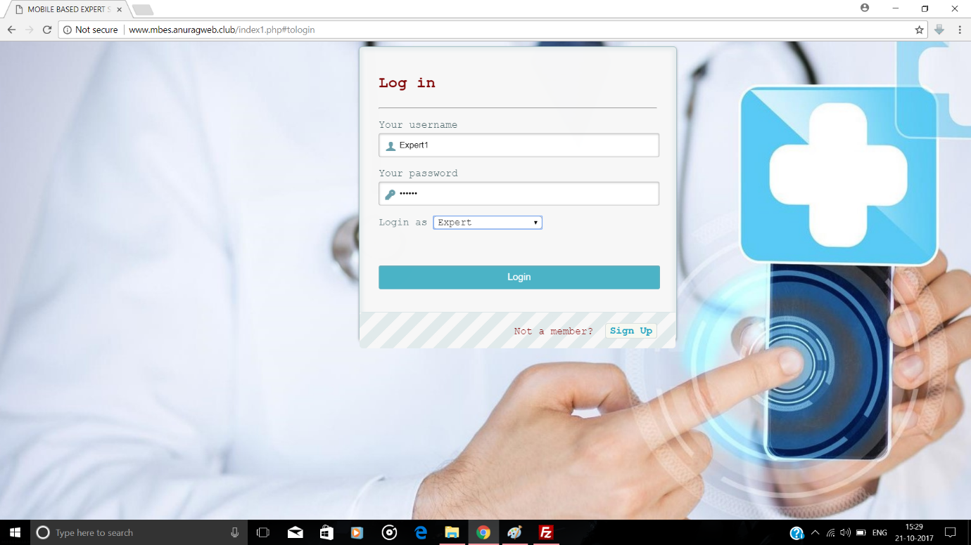

CLIENT SIGN UP FORM:
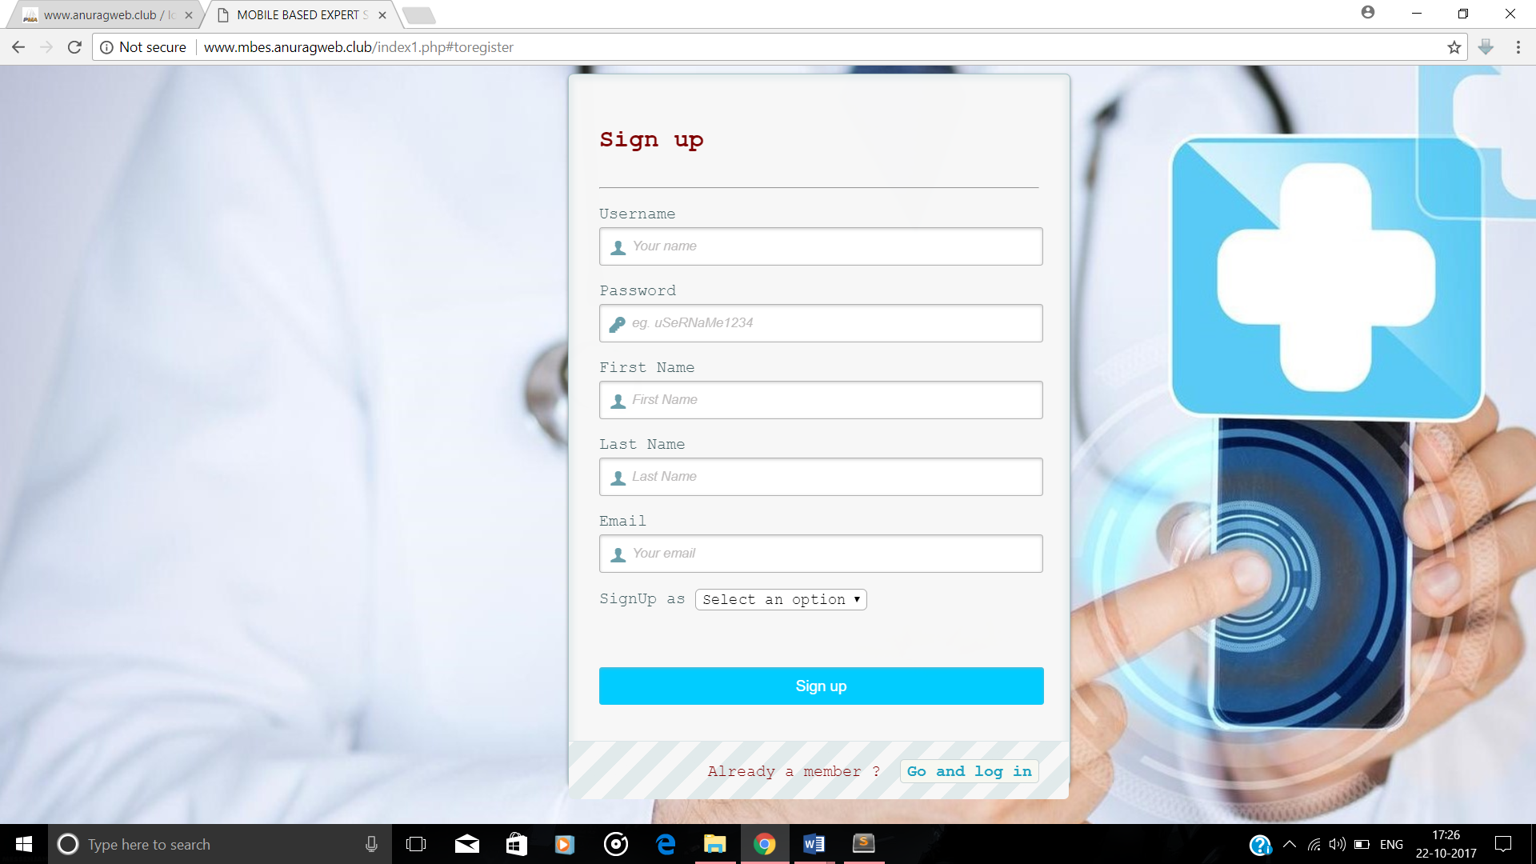

ADMIN LOGIN FORM:
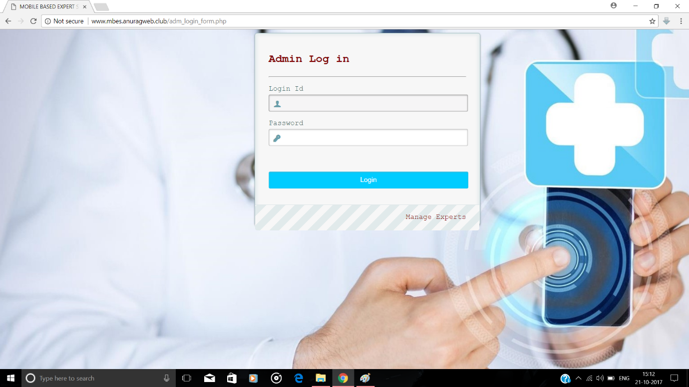

ADMIN HOME:
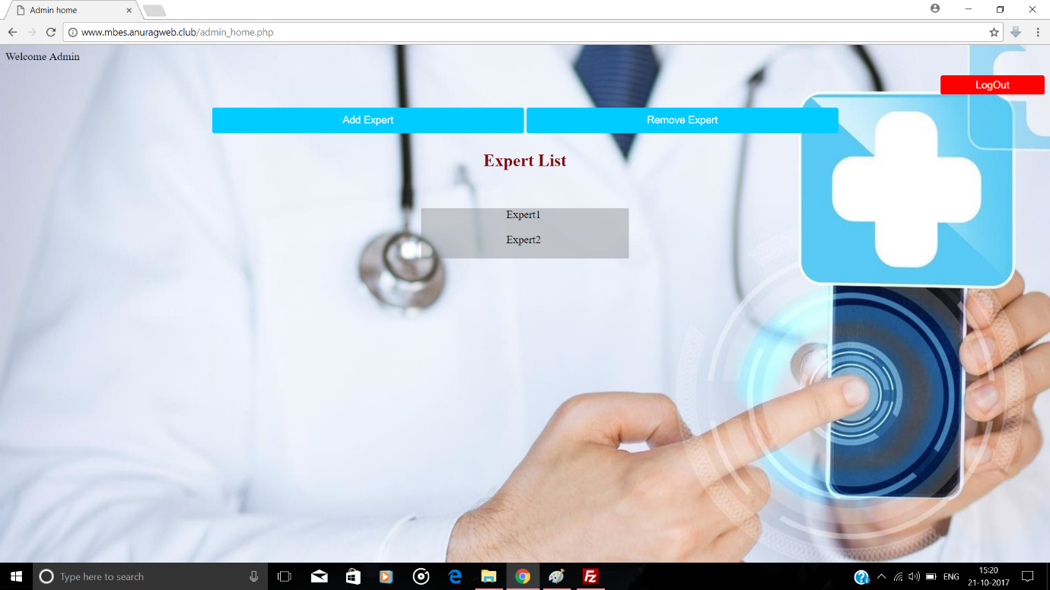

ADMIN ADD EXPERT:
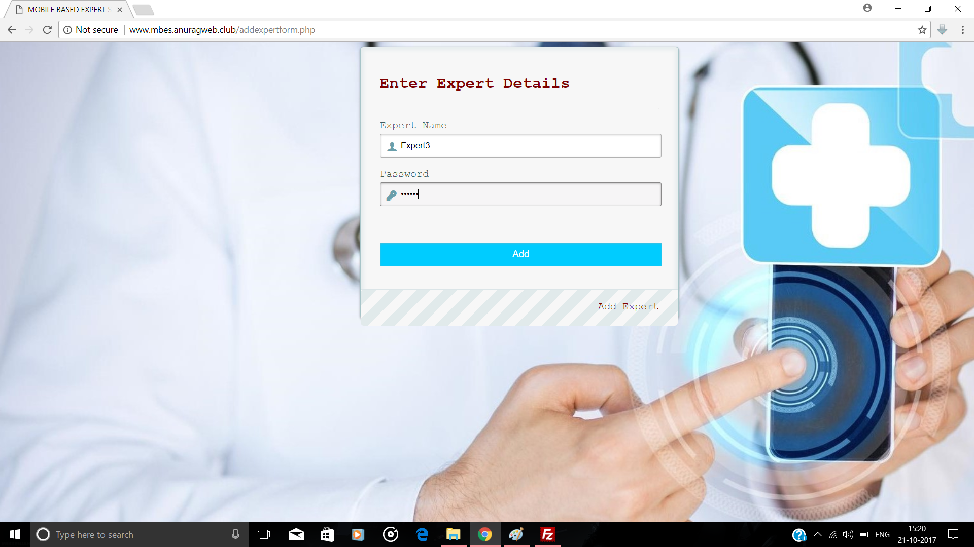

ADMIN REMOVE EXPERT:
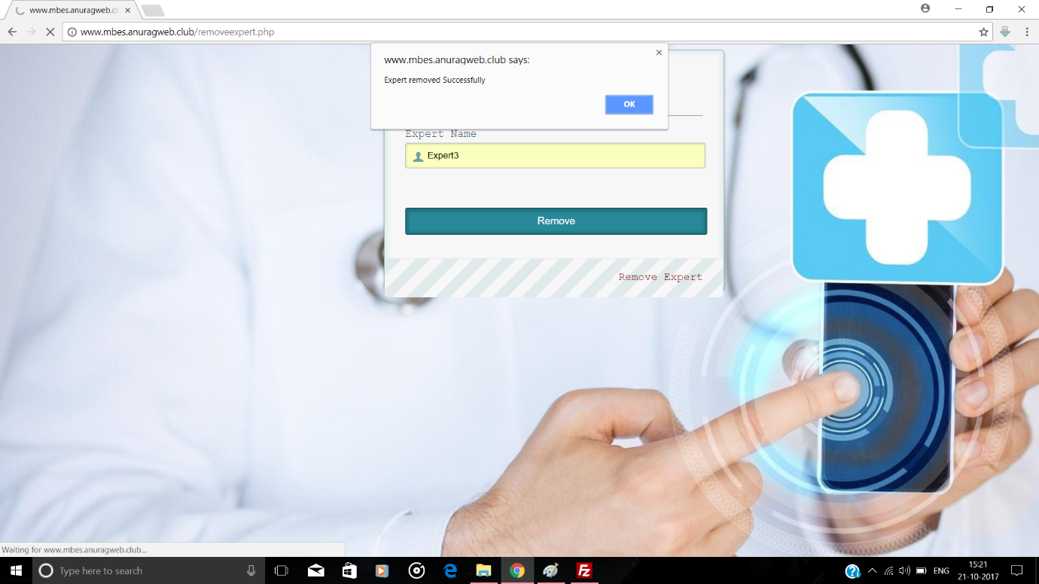

EXPERT/CLIENT HOME:
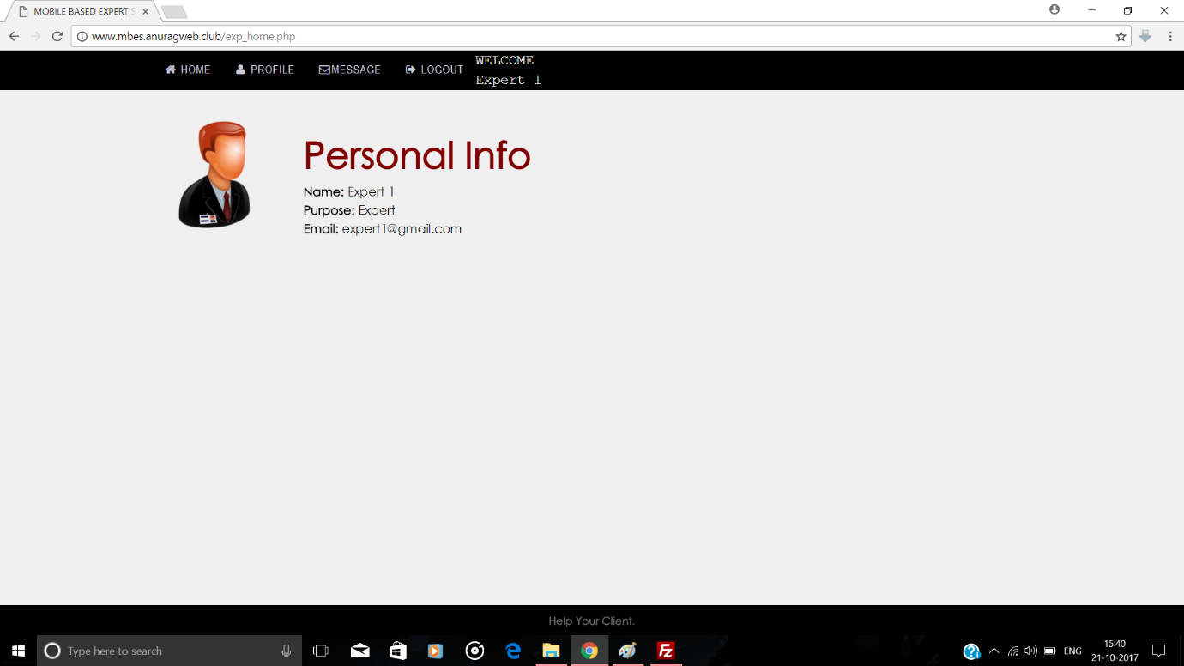

EXPERT/CLIENT PROFILE:
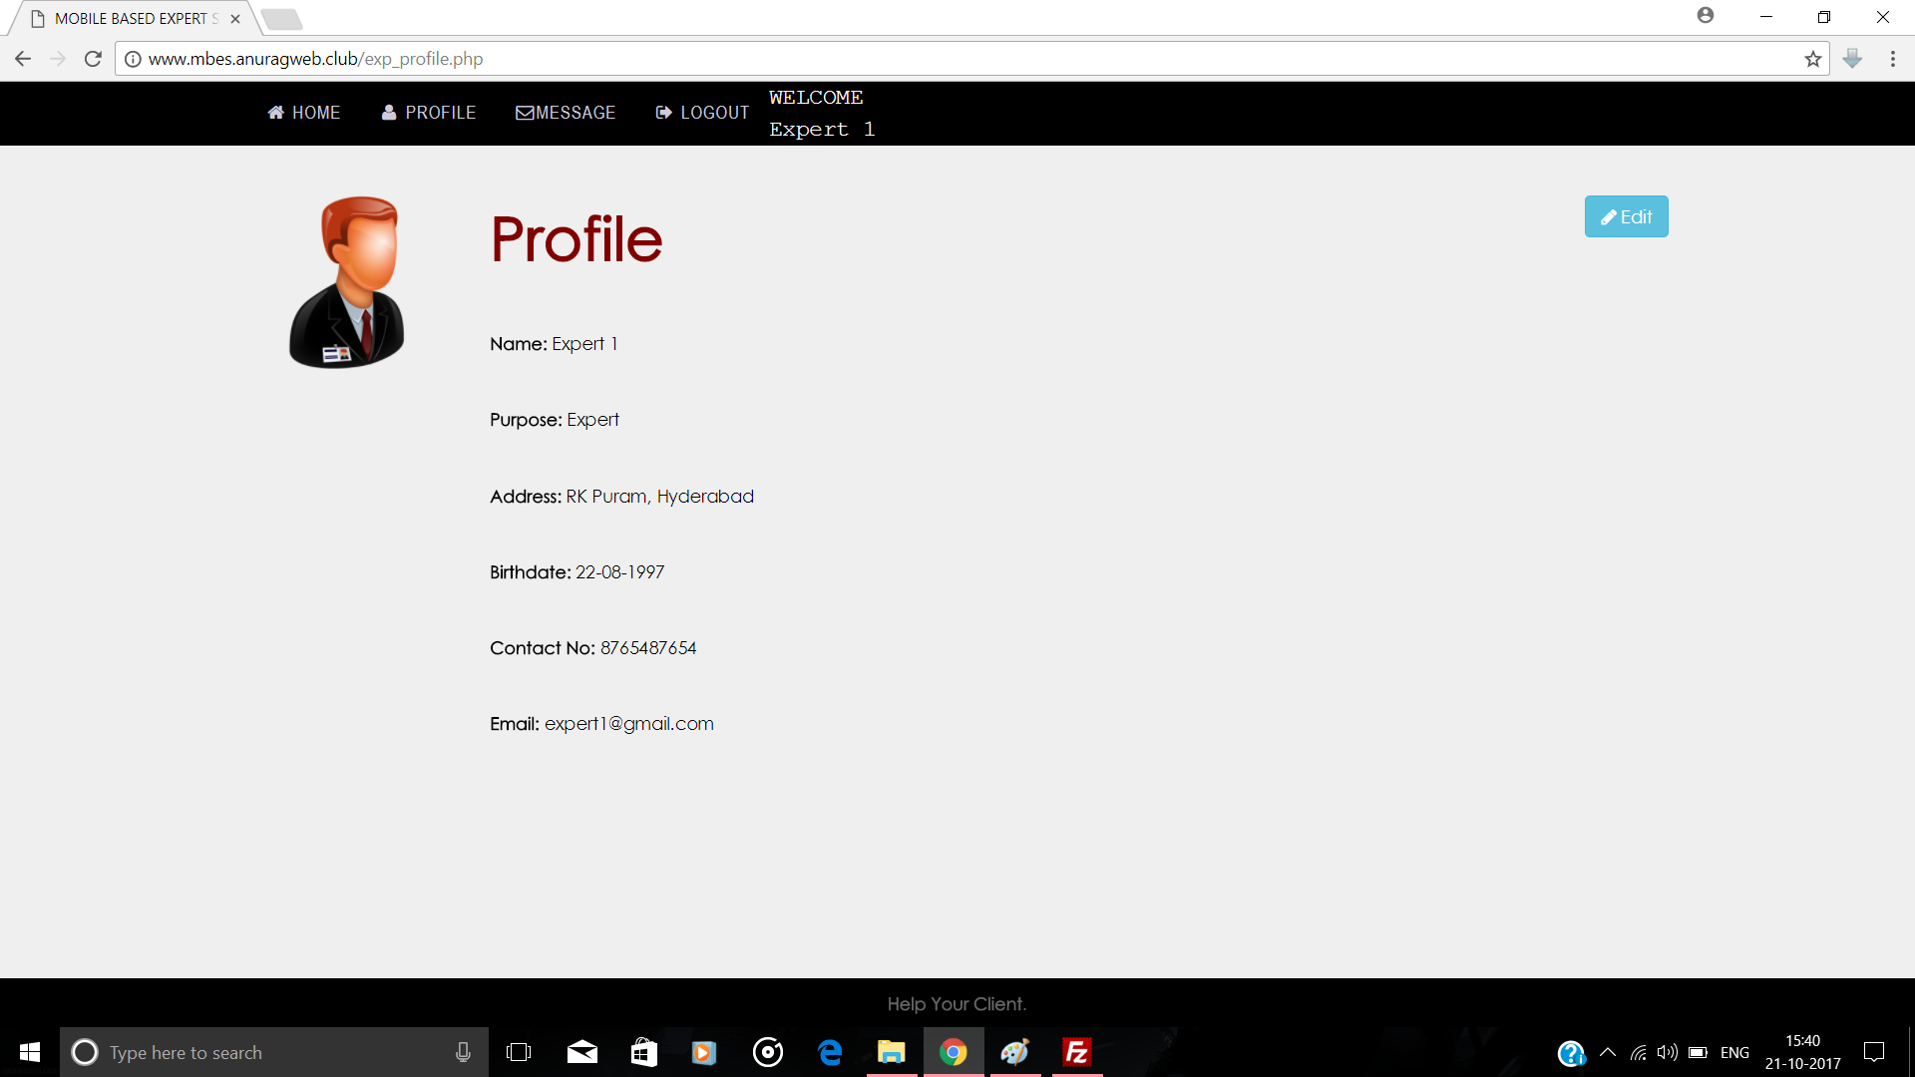

EXPERT/CLIENT EDIT PROFILE:
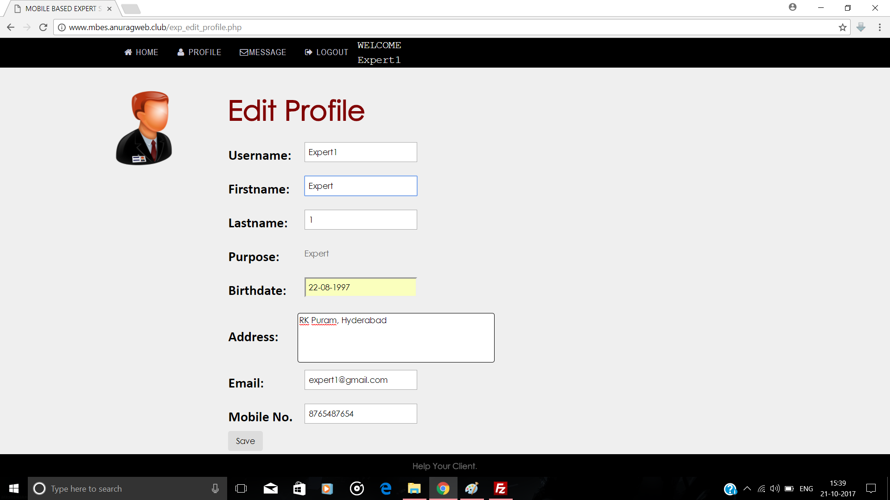

EXPERT/CLIENT MESSAGE:
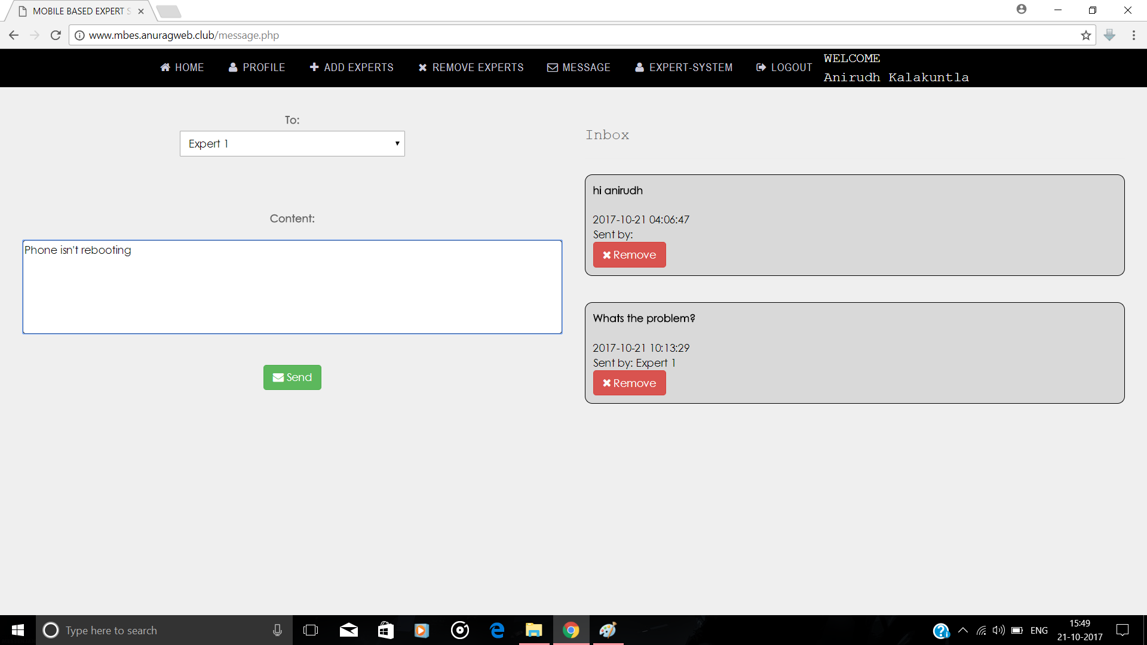

CLIENT ADD EXPERTS:
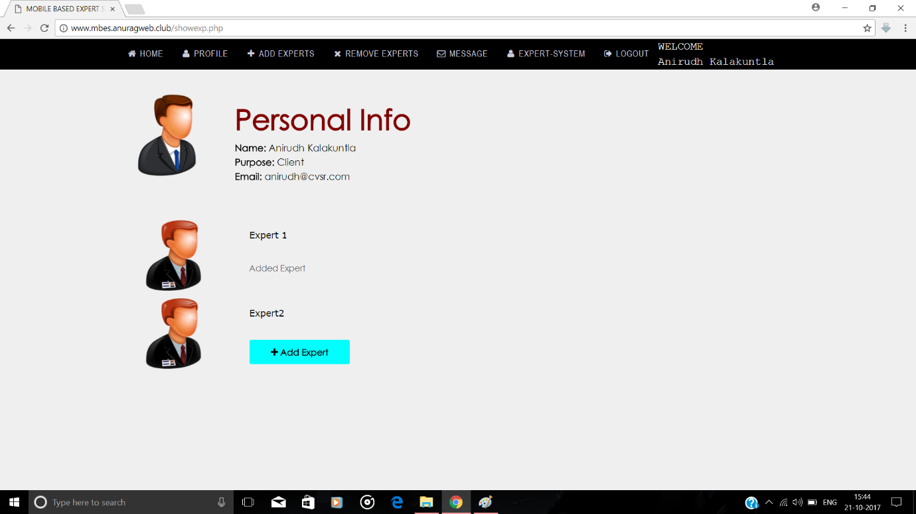

CLIENT REMOVE EXPERTS:
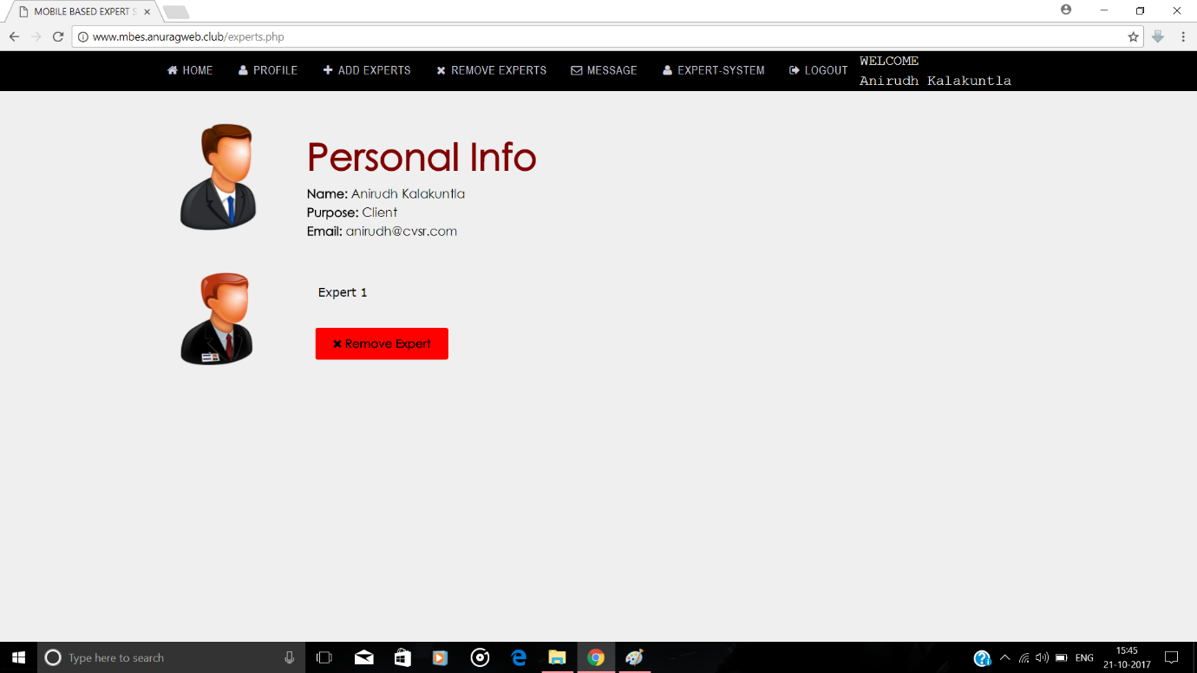

EXPERT SYSTEM:
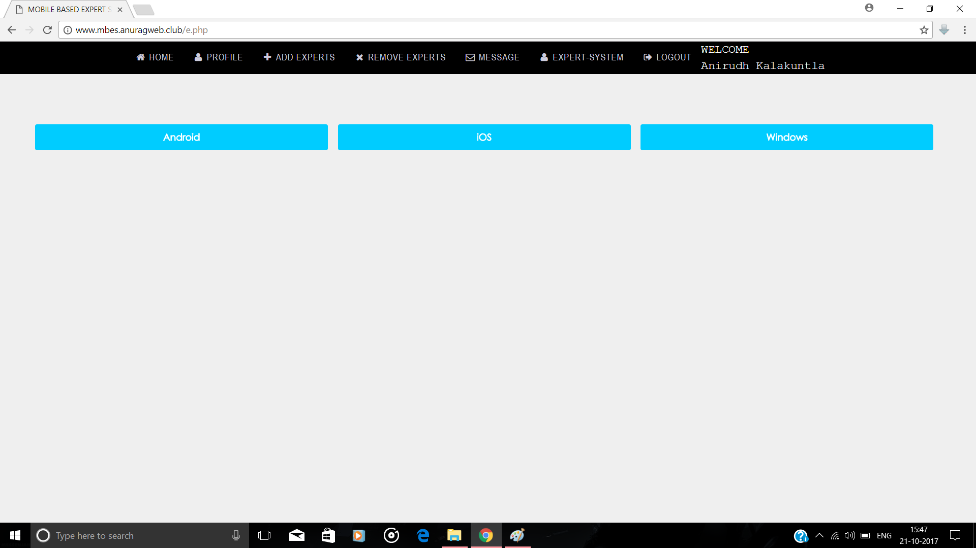
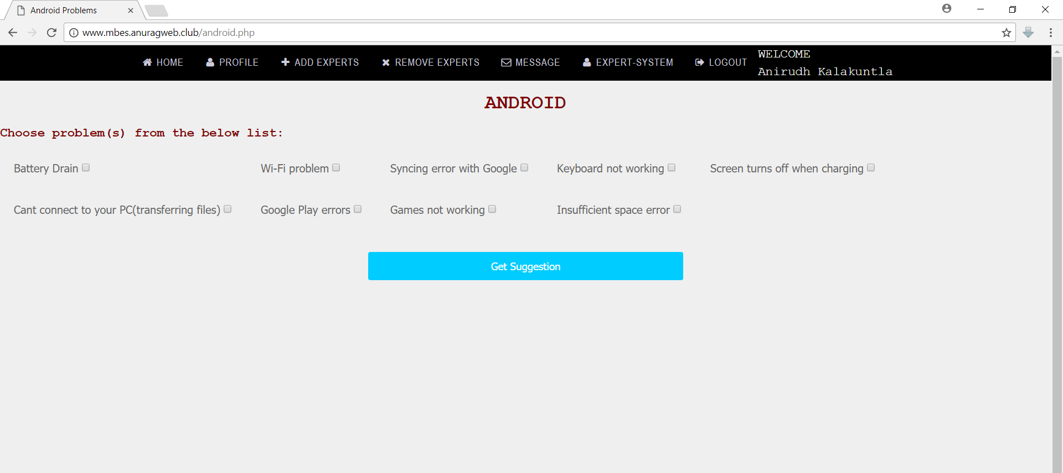
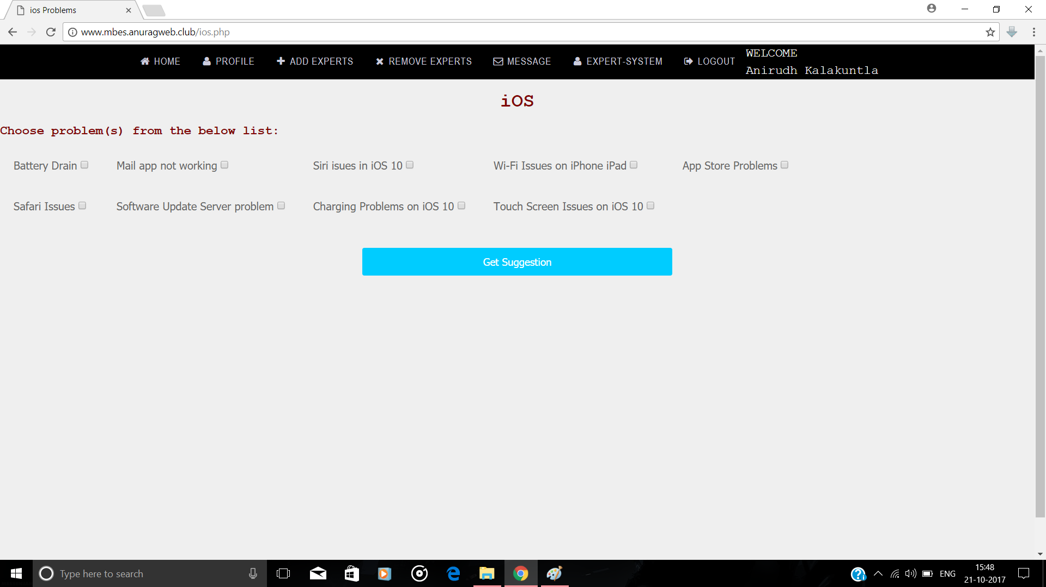
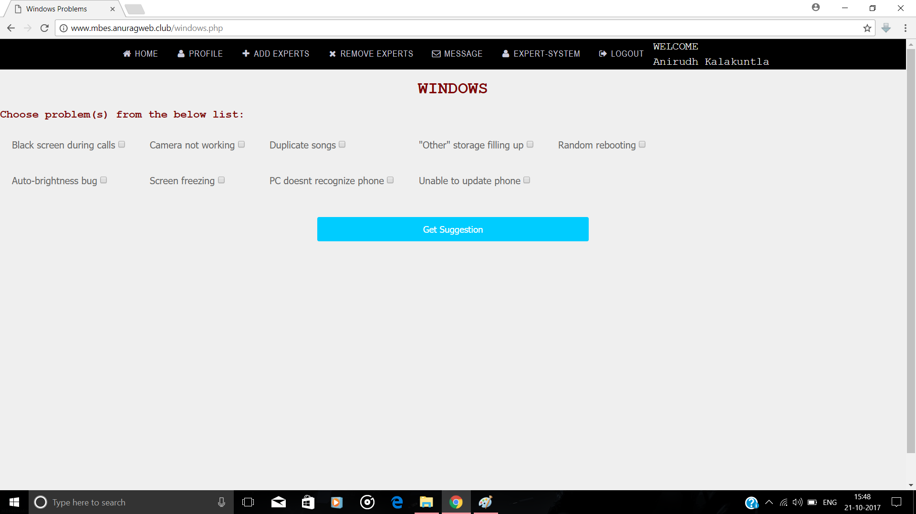
CHAPTER 3 - DATABASE AND ER DIAGRAM
3.1 ER DIAGRAM:
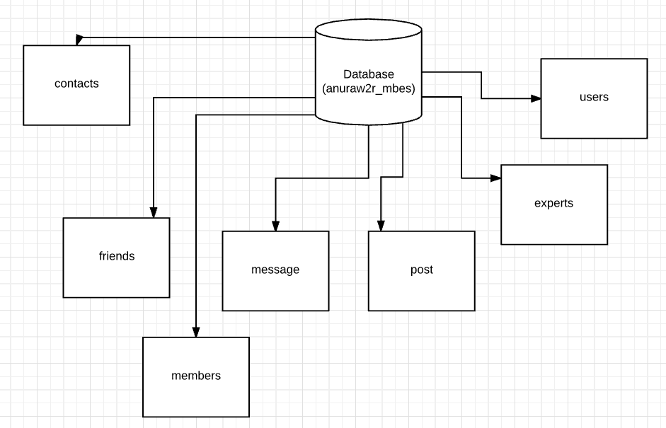
Fig 3.1.1: ER Diagram

3.2 TABLES:
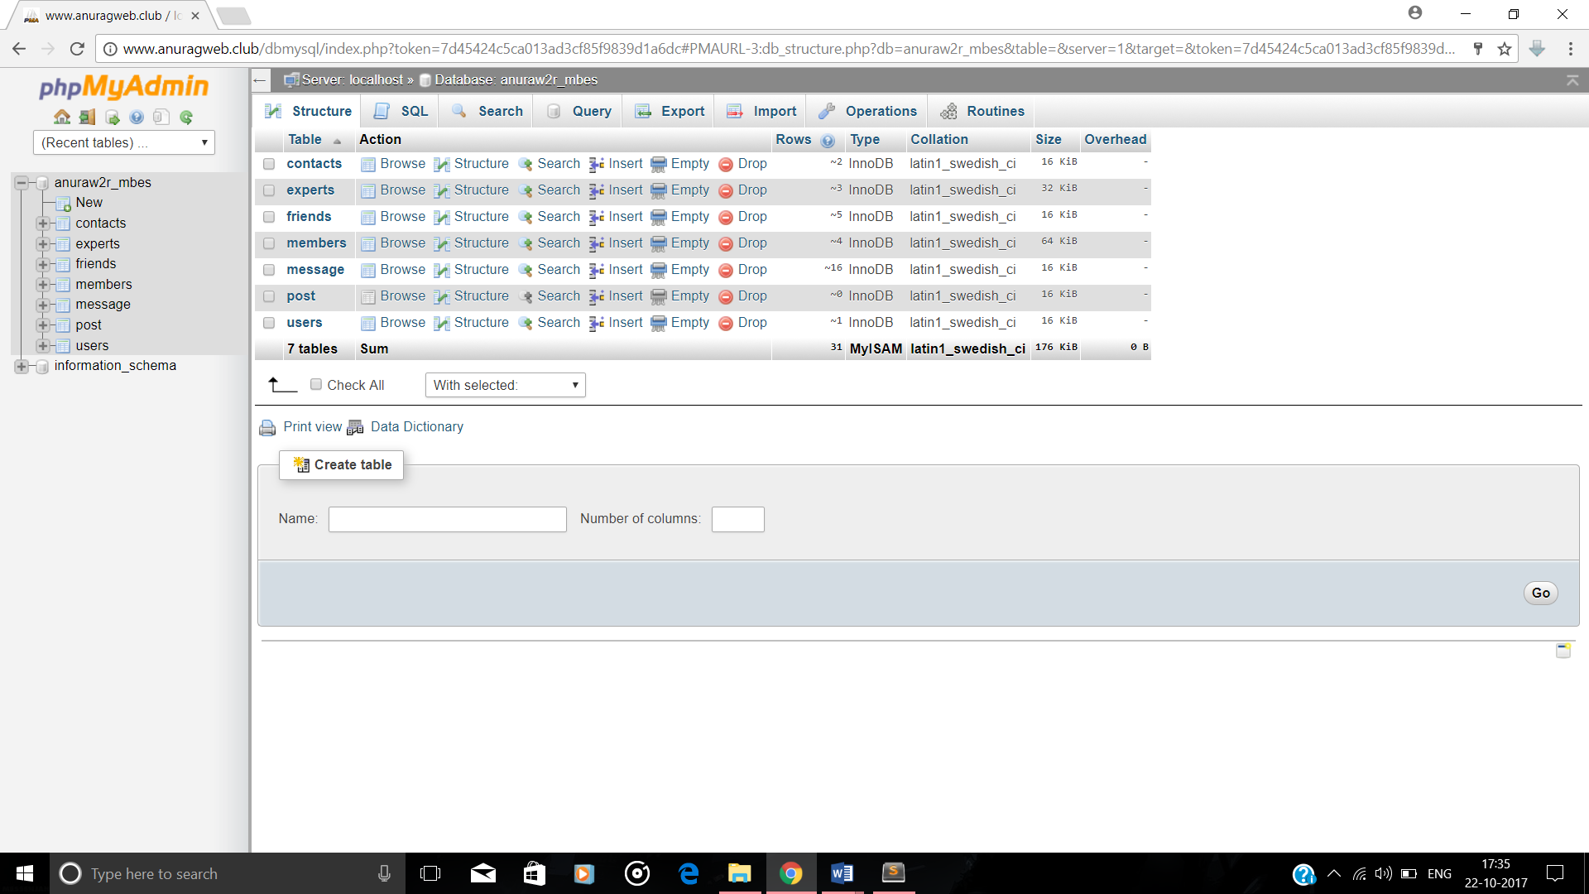

3.3 TABLE DESCRIPTION:
CONTACTS:
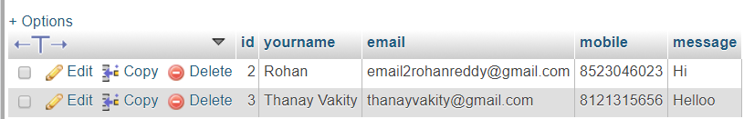

EXPERTS:
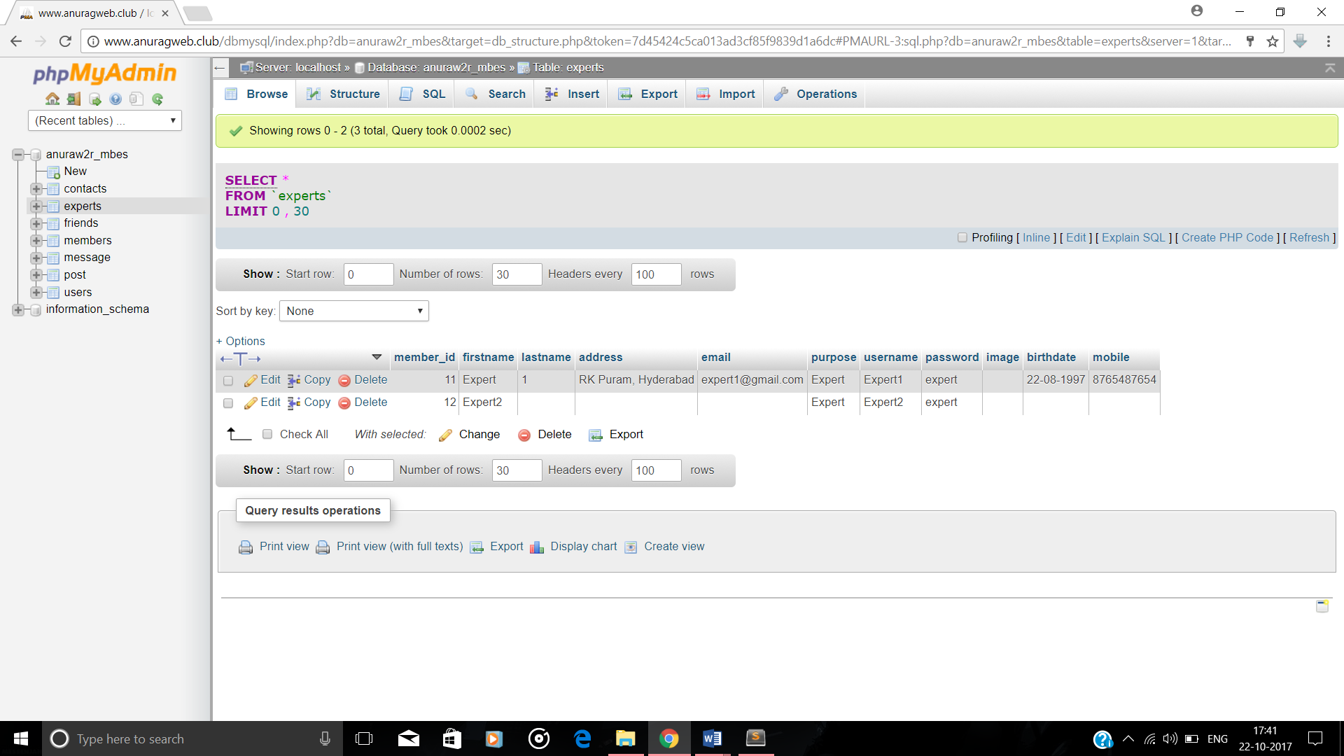

FRIENDS:
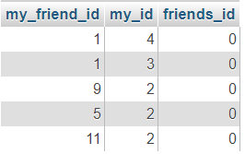

MEMBERS:
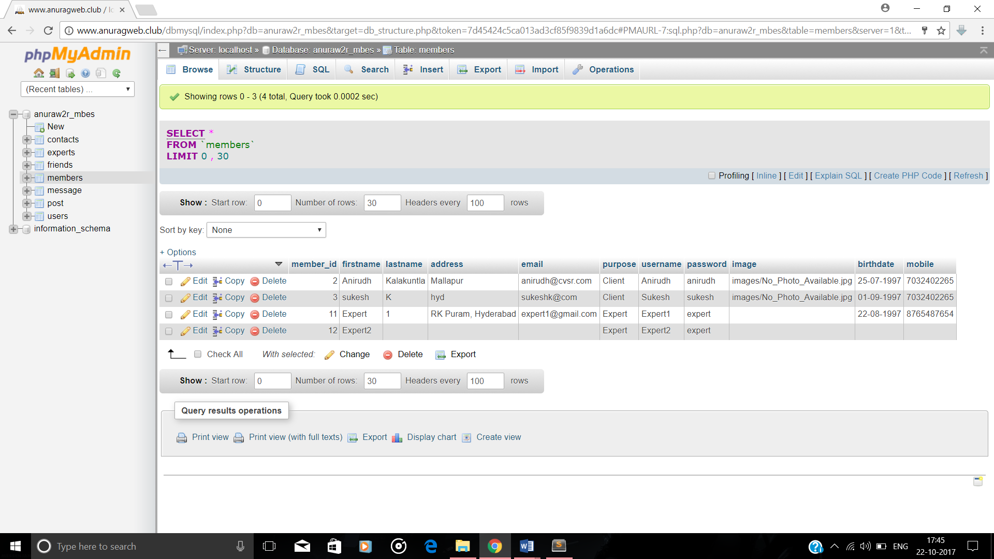

MESSAGE:
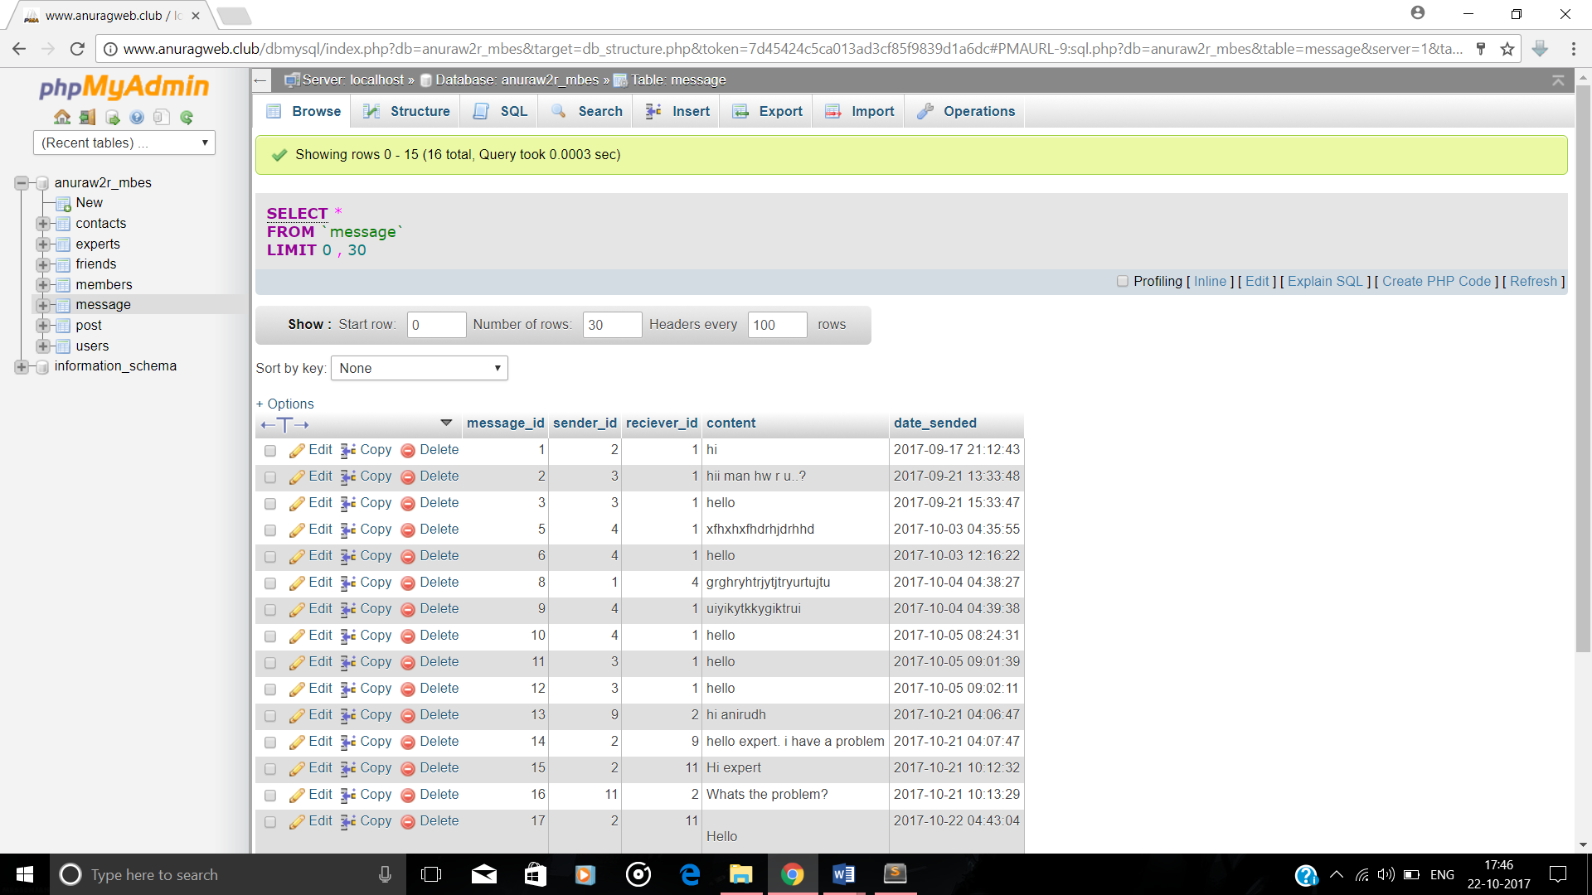

POST:
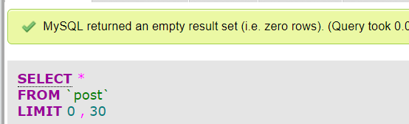

USERS:
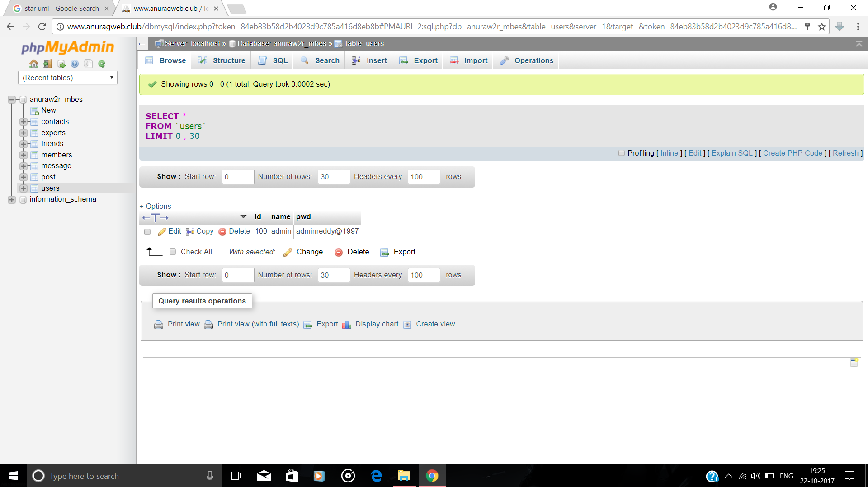

CHAPTER 4 - TESTCASES IN PROJECT

TESTCASE  ID | TESTCASE | FUNCTION BEING TESTED | INITIAL STATE | INPUT | EXPECTED OUTPUT | STATUS
1 | Homepage | Opening homepage | Power on | URL | Homepage | Success
2 | Register page | Accept details | Homepage | Fill details | Sign up successful | Success
3 | Login page | Verify username, password and purpose | Homepage | Enter details | Expert/Client/  Admin home based on purpose | Success
4 | Add/Remove Experts(Client) | Verify my_id and my_friend id | Client Profile | Click  Add or  Remove | Expert added or removed | Success
5 | Add/Remove Experts(Admin) | Check expert name | Admin home | Expert name and add or remove | Expert added or removed | Success
6 | Expert system | Problem and solution | Client profile | Check one/more checkboxes and click on get suggestion | Selected problem and its solution are displayed | Success
Table 4.1: Testcases

CHAPTER 5 - DEPLOYMENT DIAGRAM:

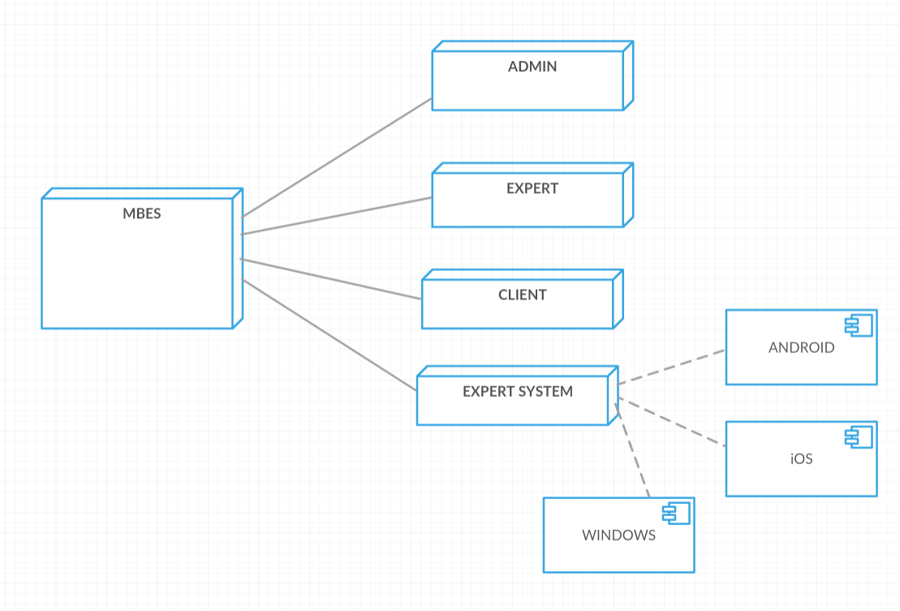
Fig 5.1: Deployment Diagram

MBES(DATABASE)
COMPONENTS:
ADMIN
EXPERT
CLIENT
EXPERT SYSTEM

CHAPTER 6 - CONCLUSION

Now a day’s people like everything to be available at their fingertips. The main aim of this project is to reduce the effort of users and save their time by providing solutions to their mobile-related problems within the reach of their hand.
The main features of the website are the client and expert can interact with each other to discuss mobile-related problems. The clients can make use of the expert system which provides suggestions/solutions generated by the computer.
Based on the usage and response to the site, we will be adding more number of problems and their solutions in the expert system and try to enhance its performance by adding new features. We will be associating with more number of experts who could provide solutions to most of the problems that our clients encounter. Also we want to add the feature that, whenever new problems are added in the website, the clients will be notified with a message to his/her mobile and mail id.

BIBLIOGRAPHY:

[1]. www.ecommerce-digest.com

[2]. www.exsys.com

[3]. www.britannica.com

[4]. www.searchhealthit.techtarget.com

[5]. www.wikipedia.com

[6]. www.tutorialspoint.com

[7]. www.cobweb.cs.uga.edu

UML DIAGRAMS CREATED BY USING:

[8]. https://www.genmymodel.com/staruml

[9]. https://creately.com/

